DAY 1

PASSPORT MANAGEMENT SYSTEM

CLASS DIAGRAM:

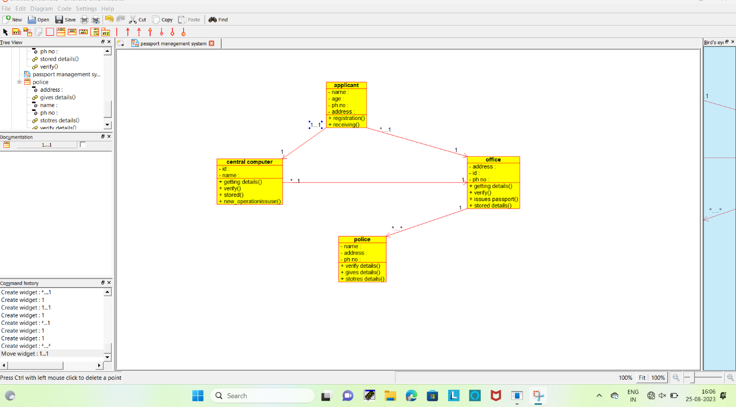

ACTIVITY DIAGRAM:

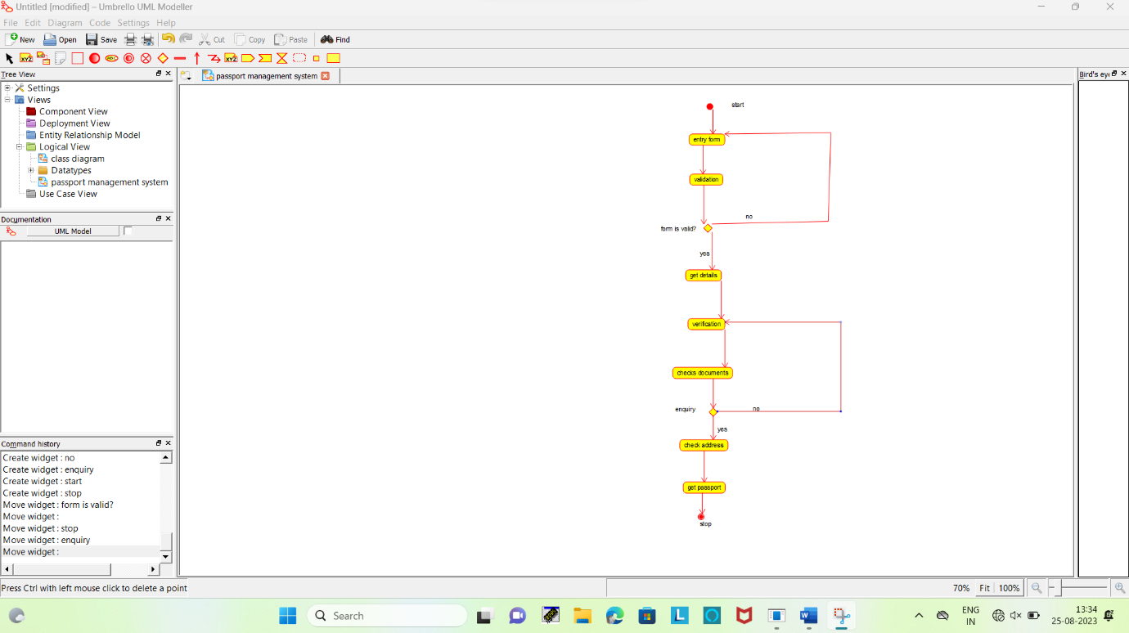

USE CASE DIAGRAM:

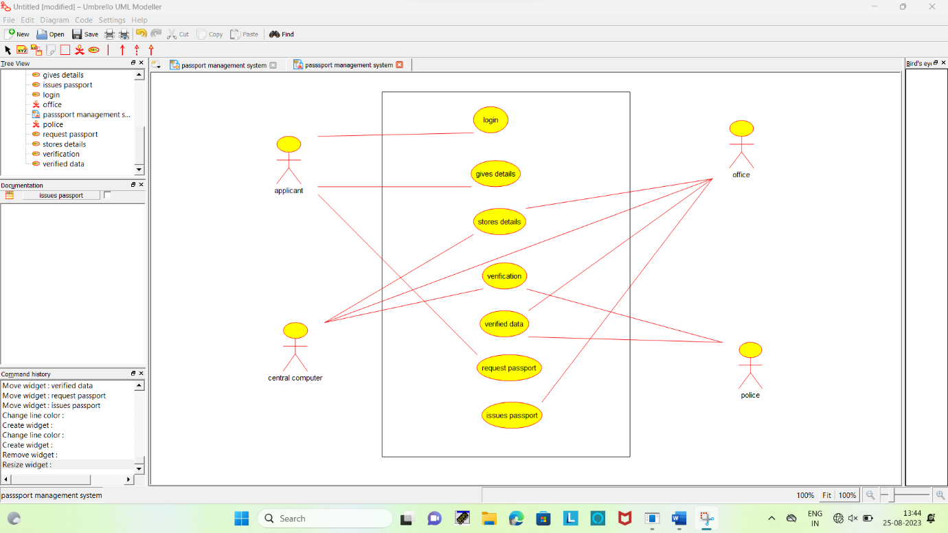

BOOK BANK SYSTEM

USE CASE DIAGRAM:

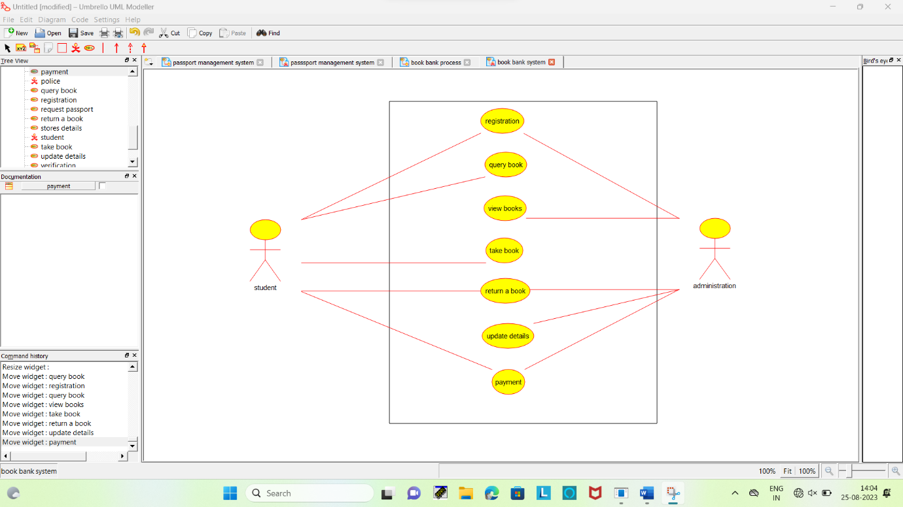

ACTIVITY DIAGRAM:

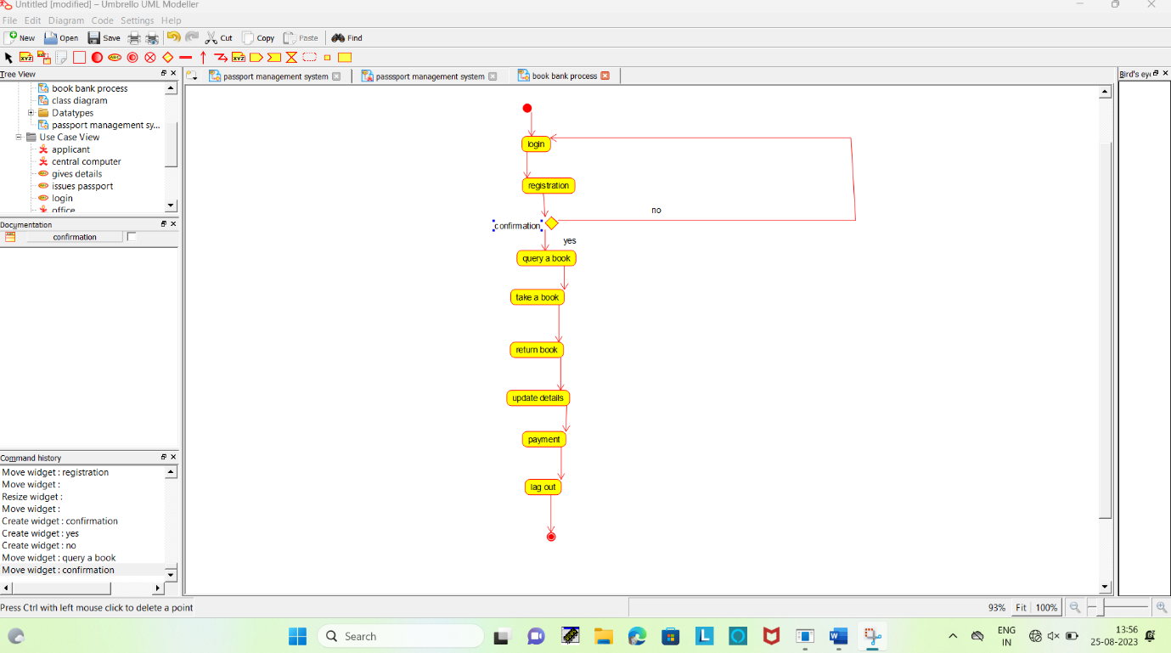

ACTIVITY DIAGRAM:

